Museum Paper
Van Gogh has always been one of my favorite artists and is one that has been very influential on me in my own work so I thought it would be fitting for me to visit the Van Gogh’s Bedrooms display at the Art Institute of Chicago. During my visit, I saw a multitude of Van Gogh’s work but the work that stood out to me were his bedroom paintings because he did so many of them. It was intriguing to me to see the minute details that changed in each depiction of the bedroom over time. I couldn’t choose just one of the Bedroom paintings to talk about so I will be talking about the three depictions and the similarities and differences I saw because I think they fit best as a series.
Van Gogh’s Bedroom originally started with just one painting of his bedroom (1888) in his new house that he called the “yellow house” and pulled much inspiration from. According to the letters from Van Gogh at the exhibit at the Art Institute, the first Bedroom painting was created to decorate the walls of his home along with many other yellow paintings for a visit he hoped to get from the French post-impressionist artist Eugène Henri Paul Gauguin whom he looked up to and was very inspired by. He loved his first painting of his bedroom so much but unfortunately it had gotten water damage so he recreated it the same dimensions and medium in a second Bedroom painting (1889) which is permanently at the Art Institute of Chicago. His third and final recreation that he made a few weeks after his second painting was a gift to his mother and sister and was slightly smaller in dimensions than the other two paintings. At the time, these three paintings served as more personal objects to Van Gogh but now are revered as one of the most famous spaces depicted in history as well as a look into Van Gogh’s personal life and mind. Each painting is expressionistic in style as that was what Van Gogh strived for and is famous for.
At this time, it was much more important for many artists, namely the expressionists, to have work that doesn’t necessarily make a subject important, but a feeling or emotion. For Van Gogh and other painters like him, painting ordinary subjects in an unordinary or original way was one of the main focuses at the time. During this time period artists were not only rejecting the classical ways of painting but even the impressionist way of painting that also was created to revolt against classical and realist painting. Because of the invention of photography, painted portraits and landscapes in perfect realism became completely unnecessary and were much more expensive to have than a photograph so artists had to make ends meet somehow. The impressionists grew out of this lack of need and started to depict ordinary, middle class subjects in a very generalized and flat way of painting. For a while this technique worked but many artists began to reject this method of painting because art had lost its spiritual and emotional qualities. From this desperation to get back the essence of art, the expressionists were born. The expressionists cared less about the subject and more about the emotion behind the subject. Suddenly the artist became much more influential and important in a painting because people wanted to see what the artist was thinking while they were painting or sculpting. Vincent Van Gogh was an expert at making his feelings known through the use of everyday subject matter.
Though the subject matter itself in the three bedroom paintings is rather simple, the significance behind the bedroom is why Van Gogh was so fond of these paintings. Van Gogh had never lived in a permanent home; he moved countless times and never had enough time in one place to consider it a home. For Van Gogh, when he moved into the yellow house in Arles, he finally felt a sense of belonging which you can see very evidently through his depictions of his bedroom. The paintings are filled with warm and exciting colors that show how uplifted Van Gogh felt at the time. Even while in a mental institution, his bedroom and the thought of home inspired Vincent yet again to create one last depiction of it.
Interestingly, Van Gogh’s third painting of his bedroom was done while he was recuperating in an asylum after a mental breakdown due to a fallout with his friend Gauguin. Evidence of a change in demeanor can be seen in the way Van Gogh depicted this final bedroom. The coloration is much darker and has more gray and neutral tones, something quite uncharacteristic of Van Gogh as he was a man who loved color. Also a lack of expression can be seen, the application of paint is actually quite reminiscent of the flat color and application used by impressionists; this final bedroom scene is quite off-putting in that you can truly see how downtrodden Van Gogh was feeling at the time he painted it. The only feeling still evident in this final painting is his love for his bedroom in the Arles house.
The main elements I found to be prevalent in each depiction of the bedroom are shape, space, color, texture, and line. What I found interesting with the shape of the bedroom scene is that Van Gogh did not paint the objects as if they were manmade but instead as if they were organic and almost living objects. Though the viewer obviously knows that a bed is a static object, it is almost like it could become like the living furniture from the movie Alice in Wonderland. Space is the most constant element used in each of the bedroom scenes and at the same time it is subtly changing throughout each picture. When I say the space changes is that the objects that occupy it seem to change and move around just as they would in real time when someone gets tired of one decoration. In each painting, there are new pictures on the walls, the most interesting of which I found to be the painting hanging above the coat rack behind the bed. It seems that the scene depicted in the painting is changing as Van Gogh’s mood is changing, in the first Bedroom the painting is happy and bright, maybe a summer day and then it progresses to barren land devoid of much color and brightness. This could also just be Van Gogh incorporating the change in seasons but I like to think that it’s symbolic of his inner struggles. Color in another dynamic element used in each painting. As each painting progresses, it seems the color gets duller as does his mood. The first and second painting are vibrant and lively, with many bright greens and pinks in contrast with the third painting which seems to revert back to the primary colors for the main source of color. Like a true expressionist, his colors consistently give sight into what Vincent was going through and how he felt about it. The next element used in Van Gogh’s Bedroom paintings is texture which is achieved through his heavy application of paint in thinner lines, thus creating divots in the surface that help to move the eye around. To me, in these works line and texture can be talked about interchangeably because they create each other and work together to get the effect of pulsing expression. Line and Texture are at their peak in the second painting especially in the floor boards, and are at their lowest in the third painting which seems reminiscent of impressionistic painting with a flatter application of the paint.
The most impactful principles of design in these paintings are unity, variety, contrast, emphasis, and proportion. Unity and variety very much work together in the Bedroom series. Variety is used in the line technique as well as color application but unity comes in because the line and color is widespread/balanced throughout the canvases. This same effect can also be seen in the way Van Gogh seems to use mainly rectangular shapes which move around the scene in the floor boards, bed, chairs, table, and picture frames. The next principle used is contrast. Contrast is used in the color difference between the window and the rest of the scene. It seems that both the darkest and lightest colors are used in the window, while less concentrated colors are used throughout the rest of the room. This leads me to the next principle which is emphasis. Possibly Van Gogh wanted to emphasize the window and its importance to him, maybe because it brought him inspiration or even just that he enjoyed the light it brought to the room. The last principle used is proportion. Though the room seems to be correct in proportion, I think the perspective makes it looked skewed which is very interesting. This was obviously an intentional interpretation of the room considering Van Gogh did it the same three times.
I thought it would be interesting to compare/contrast a very well-known expressionist to an equally well-known impressionist, so naturally I chose Claude Monet whom actually had a lot of influence on Van Gogh’s work. I specifically chose to use Monet’s Haystack. End of summer. Morning. (1891) which is one of my favorite paintings by Monet. First I would like to discuss the differences between the painting styles as they are more evident, and then the similarities. The main difference is in the content of the piece, not to get confused with the subject. The content of Monet’s painting is simply a beautiful summer morning looking at the haystacks; it was important for impressionists to only paint the scene, no inherent meaning, but the scientific aspect of it, the play of light, and the way it all works together. For Van Gogh’s paintings, the content was more about the inherent meaning, what the artist was feeling. In this respect the two artists could not be more different. However when we look at technique there are striking similarities with the application of paint creating movement. In the Haystack painting, light was the main source of this movement and the rest of the scene corresponded with it. In the Bedroom however, the main cause of movement is simply the repetition of color in the linear way the paint is applied. Also very similar is the color palette used specifically in the second version of the Bedroom and in the Haystack. Both paintings are vibrant and teeming with life and a playfulness. Though the artists’ intentions with the color schemes were very different (one for likeness and the other for emotional value) the similarity in color palette is striking.
Like I stated in my intro, Van Gogh has always been one of my favorite artists who continues to inspire my art. I already had a great appreciation for his artistic style, but now that I have studied his intentions, the events going on in his life, and the historical context when his paintings were created I have a newfound and deeper appreciation for his works. Learning about the views of not only Van Gogh but also other expressionists like him has really aided in my understanding of the style as well as better ways to implement expressionism into my own work. I hope to continue learning more about the styles and techniques artists used and still use today.

Notes
- In the 37 years Van Gogh was living, he moved 37 times.
- The cause of Van Gogh’s death is still a mystery but the most supported cause is suicide.
- Van Gogh’s work was inspired very much by his dreams, “I dream of painting and then I paint my dream” –Vincent Van Gogh.
- The Art Institute used new technology to dissect each color used in the Bedroom paintings, thus being able to restore them as accurately as possible.
- Van Gogh’s paintings all were received by his grandson Vincent Willem, whom could have made a lot of money off of them but chose not to do so because he simply didn’t want to.
- Van Gogh’s brother Theo was institutionalized after Vincent’s death and died months after.

Works Cited
Under Cover: The Science of Van Gogh's Bedrooms. Perf. Gloria Groom, Francesca Casadio. Art Institute of Chicago, 2016. Part of Exhibit.
Van Gogh, Vincent. Letter to Theo Van Gogh. N.d. MS. N.p.
Van Gogh's Descendants: Machteld Van Laer with Gloria Groom. Perf. Machteld Van Laer, Gloria Groom. Art Institute of Chicago, 2016. Part of Exhibit.
"The Bedroom - Van Gogh Museum." Van Gogh Museum. Van Gogh Museum Foundation, n.d. Web. 02 May 2016.
"Vincent Van Gogh." Art & Paintings. Modelo Awesome Inc., n.d. Web. 02 May 2016.
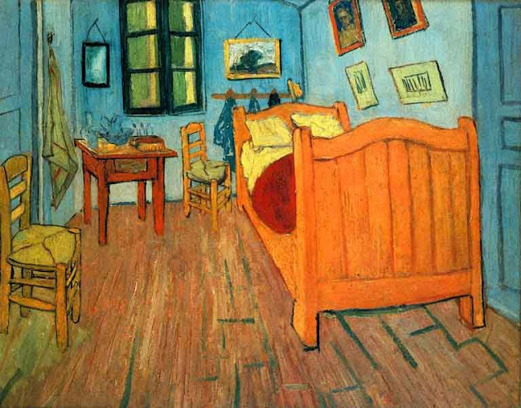
Van Gogh, Vincent. Bedroom in Arles Version One. 1888. Oil on canvas. Art Institute of Chicago, Chicago, IL.
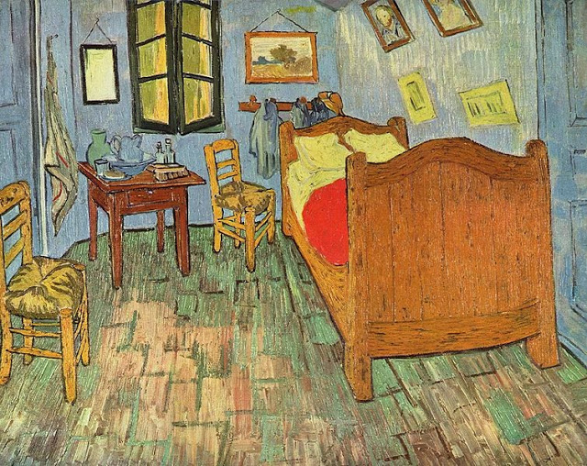
Van Gogh, Vincent. Bedroom in Arles Version Two. 1888. Oil on canvas. Art Institute of Chicago, Chicago, IL.
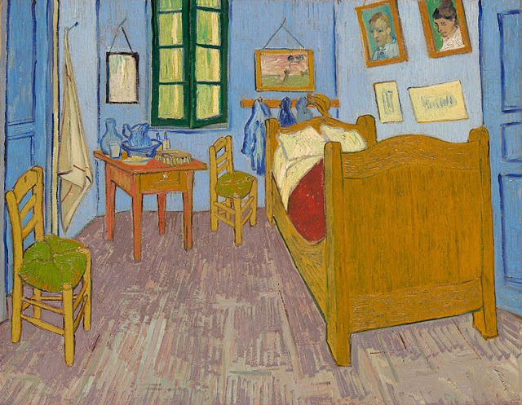
Van Gogh, Vincent. Bedroom in Arles Version Three. 1888. Oil on canvas. Art Institute of Chicago, Chicago, IL.
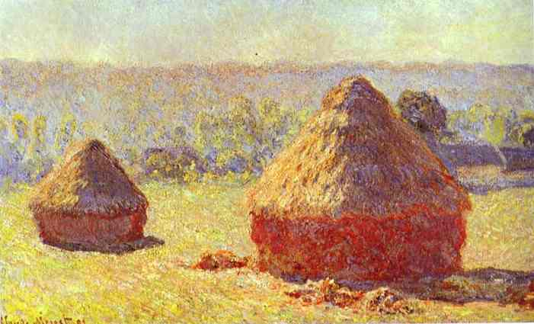
Monet, Claude. Haystack. End of Summer. Morning. 1891. Oil on canvas.

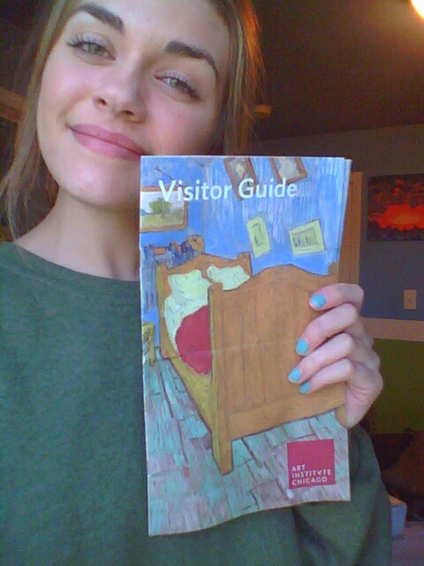
Here is a picture of me with my Visitor Guide from the exhibit. I completely forgot to take a picture outside of the museum so I hope this works. I also have my tickets from that day somewhere if more proof is required.

