
Tinker Hatfield 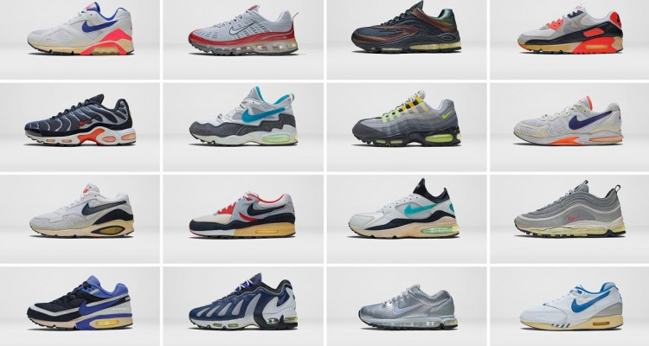
The Artist: Tinker Hatfield is an American shoe designer born in Hillsboro, Oregon in 1952. Growing up, he was heavily involved in many sports such as basketball, football, and mainly track and field. His interest in design began in college where he met his mentor and inspiration, coach Bill Bowerman who built Tinker a special pair of track spikes when he tore his ankle after a 17-foot fall. It was this event that peaked Tinker’s interest in architecture and his love for drawing which propelled him through his college years where he shadowed his beloved coach and mentor. After college, Tinker entered a 24-hour design competition for Nike which he won and only two days later was offered a job designing for Nike where he would later become the lead designer. He has worked with many famous athletes such as Michael Jordan to create the infamous Air Jordan shoe that is one of the most well-known athletic shoes world-wide. He also worked to design the first ever self-lacing shoe from the classic movie Back to the Future. Tinker Hatfield is without a doubt one of the most innovative and creative shoe designers in history and changed the way the world looks at athletic footwear.
“A basic design is always functional, but a great one will say something.” -Tinker Hatfield
“If people don’t either love or hate your work, you just haven’t done enough.” -Tinker Hatfield

Art Criticism: Quotes about Tinker Hatfield
“With the Chicago Bulls, Michael Jordan had Scottie Pippen…with Nike, Jordan has Tinker Hatfield – largely unknown by the general public, but a prized sidekick who has helped sell billions of dollars of shoes.” -Josh Peter USA Today Sports
“Tinker had a way of somehow grasping that ethos and combining it with the greatness of Jordan and fusing that into a sneaker…so the Jordan brand becomes larger than life.” -Bobbito Garcia, radio DJ, sneaker connoisseur
“For him to come up with that concept, and then have the consumers connect…the best story-telling product we’ve ever done was probably the twenties.” -Michael Jordan on Tinker Hatfield’s design of the Jordan 20s
It is clear that Tinker Hatfield is revered as one of the greatest shoe designers of all time, one that is essential to the industry and its success. Not only did Hatfield create a recognizable brand for himself, but he created a brand and a style for an entire company that is still relevant today more than 25 years after he created his first Nike shoe. Hatfield’s ability to tell story through design is the connector between product and consumer and serves as a model for the growing industry of design.
How does Tinker use both the signature/identity of the Nike brand while also maintaining the integrity of his own identity within the shoes? Why is that important for designers to do?

The Artwork: Though not a traditional visual artist, Hatfield’s work serves as a model of the modern American consumer culture and what we hold important and why we buy things. He is inspired by things he sees in his everyday life such as architecture, modes of transportation, graffiti, pop art as well as being inspired by specific athletes who he is designing shoes after/for like Michael Jordan. He has a specific vision in mind for each shoe he creates from the basic element of the fit of the shoe all the way up to the complex workings of the shoe to improve performance. His process begins with just talking or writing notes about the things he interacts with every day and he then begins to create random sketches as seen below, sometimes just starting off with a symbol and other times already having a full design in mind. While his designs aren’t made like fine art with clear intention of meaning, it is evident that not only does Tinker himself find meaning in his shoes, but so do the thousands of people who purchase them and wear them.
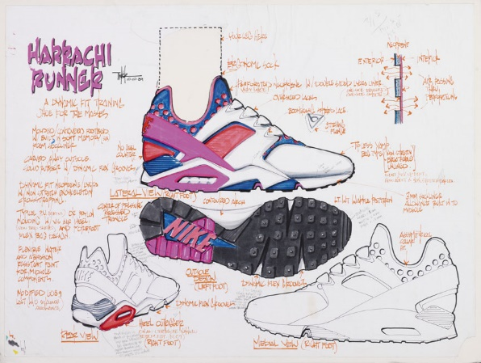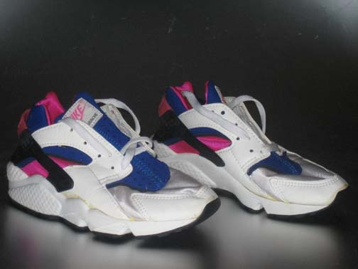
Sketch for the Huarache Runner 1989 The Huarache Runner circa 1981
Activity: ask students to think about the things they interact with daily…what of these things stick out to you or are important to you? How can you combine your style with the style of the object(s) you chose to create an interesting design? Have them create thumbnail sketches of a symbol that represents this object or interaction.

Structural Frame: What role does form play in Tinker’s designs? Does the aesthetic add to the function of the shoes or is it arbitrary…why/why not? How do the principals and elements aid Tinker in his story telling?
Cultural Frame: How does a brand like Nike function in the world? Why do we buy these products? When we make art for people to purchase what does that say? What other images or products can you think of that are based off a specific person? What does that mean to purchase someone’s “signature”?
Postmodern Frame: What commentary or stories is Tinker telling about the athletes he designs for? What ideas is Tinker challenging about conventional shoe making/why is that important to his practice? What has he changed for the athletic shoe industry?
Vocab:
Consumer culture: the economy is focused on the selling of consumer goods and the spending of consumer money. The production of goods is based on the consumer.
Design: the purpose, planning, or intention that is behind a piece of work (could be any man-made object not just art)
Street art: visual art created in public locations such as on buildings, in parks, sidewalks. Typical media is spray paint, chalk, stencils, sculpture, stickers.
Pop culture: modern culture based on mass media aimed particularly at young people
The world: Hatfield’s designs tell a story about where they come from and who they represent. How does this compare to shoes made in history? How has the function of shoes changed? What other products have made this shift in functionality? Why is this important in American culture? Compare and contrast the two designs below.
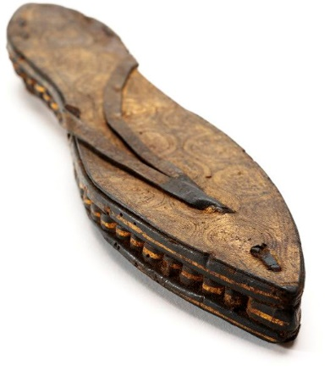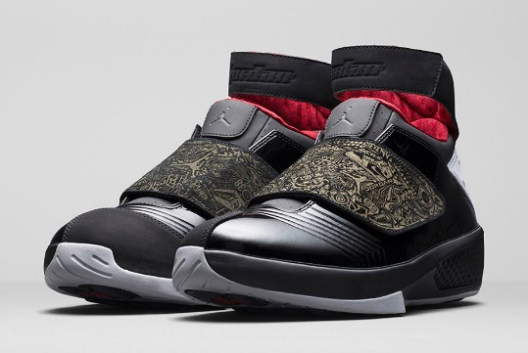
Egypt, ca. 30 B.C. Jordan 20, 2005

The audience: Though anyone could purchase Tinker’s designs, most of his audience/consumers are athletes or people who collect his shoes simply for display and not to wear them. Because the majority of his shoes are basketball shoes, many players from varying cultural and economical backgrounds wear them and thus they appeal to a wide variety of cultures and not simply wealthy, white males as other products may. How is this important to the branding of these shoes? How does this propel the Nike brand further than other brands in America? How does the accessibility of his designs connect to other artists in the world/what other types of art are easily accessed?
Keith Haring: an artist that worked with similar concepts was the 80s street artist, Keith Haring whose goal was to create “truly public art” that was accessible to the general public outside of the small art world. He too created an easily recognizable brand that was sought after by many people, so much so that he opened up his own shop in 1986, the Pop Shop, to make his work even more accessible to everyone. How is this similar to what Tinker Hatfield does with his shoes? What connections to pop culture do both Tinker Hatfield and Keith Haring share/why is pop culture essential to their brands? How do Haring and Hatfield use iconography in their work?
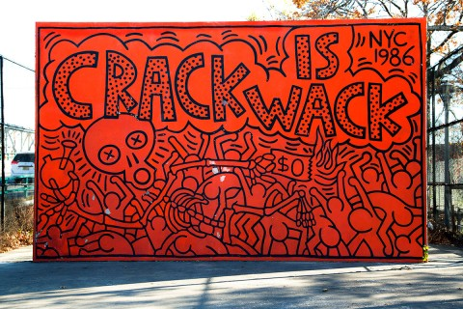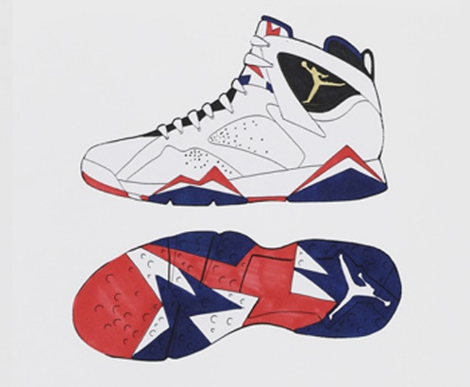
“Crack is wack”, 1986 Olympic Jordan 7, 1992

Art making: have students begin by reflecting upon themselves…what do they like to do? What’s important to them? What do they want to say to the world? Then have each student create a few thumbnail sketches of icons or symbols to represent what they are saying about themselves. Turn the icon they feel most represents them into a finished drawing or painting and then have them think about what type of product they could put their symbol on and why they would choose that specific product. Have them research the makings of the product and then create sketches of the make of theirs...how do they want it to feel? Is fit important? Does it do something specific? After they have made sketches have them create a finished piece of work that showcases their product with their signature symbol on it next to their original piece that just shows the symbol. Were they successful in telling their story? Who would buy their product? Then write a brief artist statement about choices in material, content, and design.

Resources:
Documentary Abstract: the Art of Design season 1 episode 2 Tinker Hatfield
https://news.nike.com/tinker-hatfield

