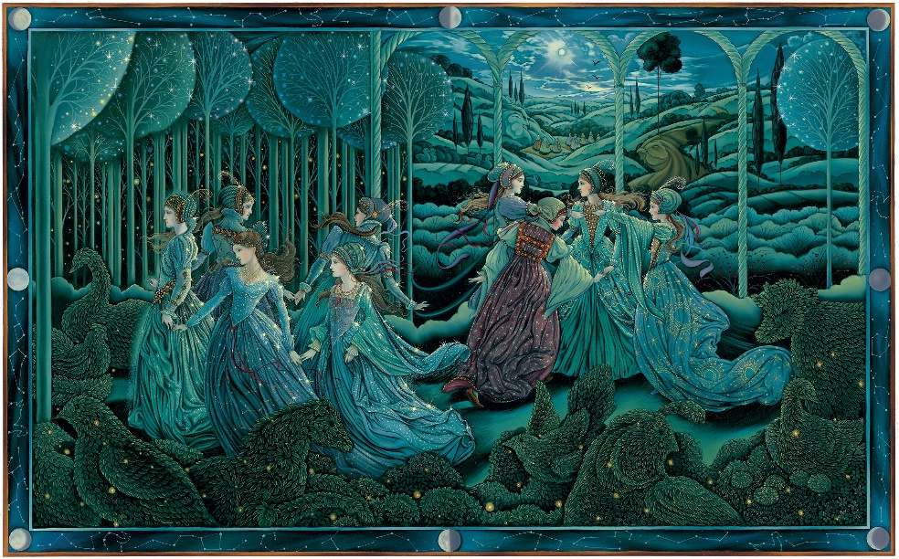
“I paint in oils on a smooth primed surface. I paint opaquely on the first layer, then glaze and detail on two to three more layers. I started painting in oils in middle school and I loved everything about oil painting from the start and never stopped”

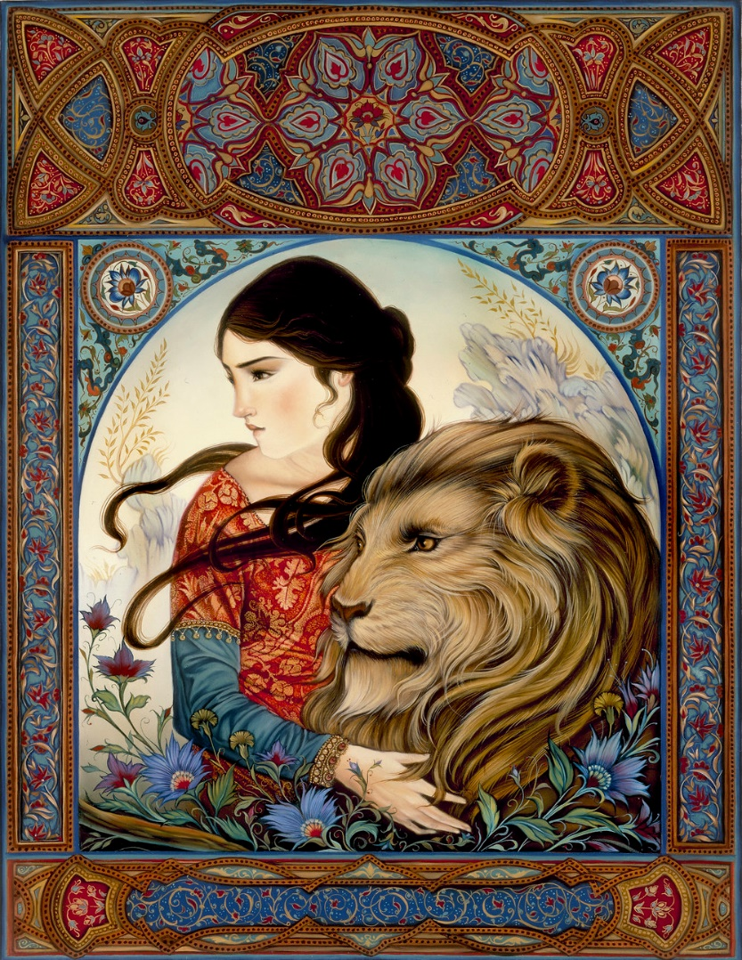
Frames Guided Discussion/think-pair-share
Subjective: What do you observe about the artwork? What do you feel when you first look at this image? What symbols do you see being used in the artwork? Does it remind you of anything you have seen before?

Structural: What does the frame add to the composition of the artwork? What materials are used to create this work? Where would you find this image? (in a book, gallery, someone’s house etc.) What types of stylistic choices did the artist make with the elements and principles? (composition, color, movement, pattern, space, balance, emphasis, repetition, etc.)

Cultural: Where in the world would you find an image like this? What time period does this take place in/does it even fit in a time period? What message is this image telling about the world? What does a lion symbolize in cultures around the world? How would you read this image differently from someone who lives in China or Africa?

Allow the students to have time to write about these questions in their visual journals, and then have them discuss their thinking with a table group or partner. After writing and discussing, have the students share out their favorite answers with the class in a student lead discussion.
Laurel Long is a storybook illustrator who also works as a Professor in the Art Department at California State University, Northridge. Laurel creates whimsical paintings illustrating well known fairytales and stories. In an interview with Miroir Magazine, Laurel said she started off “with [her] interest in Northern Renaissance paintings. These were religious paintings intended for personal devotion. They were intricate and detailed. They invited the viewer closer and into a private, miniature world. These timeless, narrative pictures created a passageway through which the viewer could journey away from the real world and into an eternal world. The idea of this one-to-one connection between the individual and the art, and the creation of an alternate reality has inspired [her] work”. Her picture book The Mightiest Heart by Lynn Cullen was awarded the Gold Medal by the Society of Illustrators and her rendition of The Twelve Days of Christmas was featured in The New York Times Book Review. A critic from the book review wrote "Here's a song whose lyrics everyone knows and that therefore demands something spectacular to distinguish it. This version, sumptuously illustrated by Laurel Long certainly delivers. Each spread has its own elegant palette, elaborately bordered like an early Renaissance tableau, making even three French hens feel like a gift that that might be desirable. An image of nine Botticelli women dancing amid topiary animals and fairy lit trees is sure to enchant."
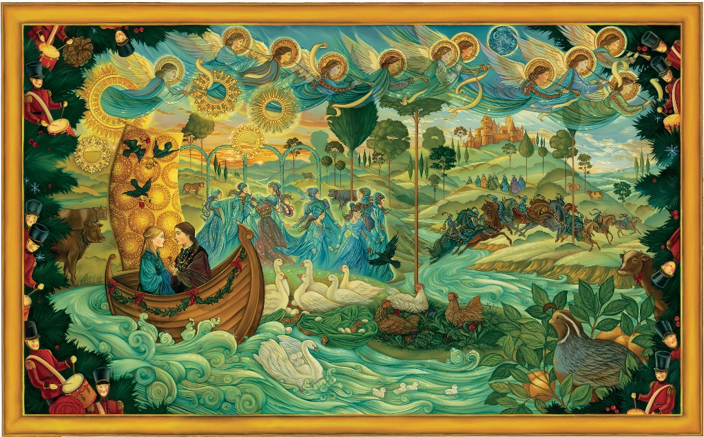
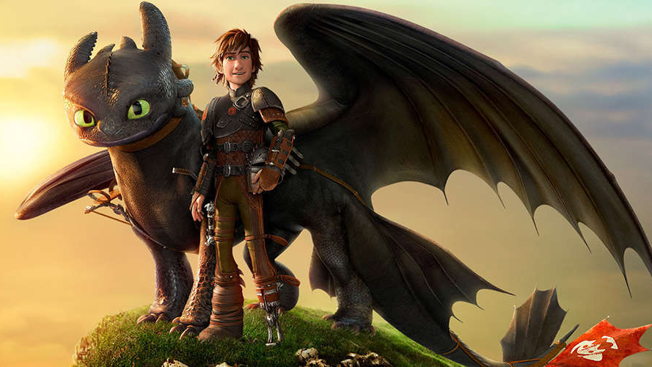
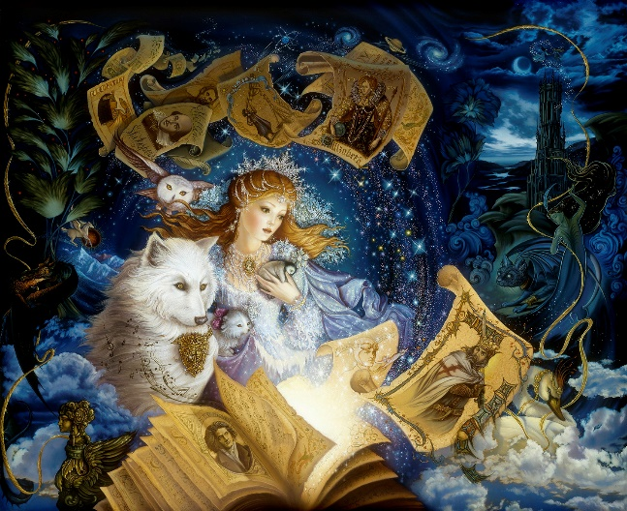
Vocabulary:
Illustration: to use drawings, pictures, etc. in order to explain or narrate a story
Animation: a method in which pictures are manipulated to appear as moving images. Today most animation is computer generated.
Dynamic: expressing an action, activity, event, or process
Scene: a sequence of continuous action in a play, movie, book, etc.
Frame: a single, complete picture in a series forming a movie, video, etc.
On the left is an illustration of Holly Claus by Laurel Long and the right is a still from the movie “How to Train Your Dragon II”. Have the students analyze each image in a group discussion with the class.
Discussion:
How is narrating a story different in a picture book vs. a movie? How is it similar? What is the function of a movie? What is the function of a book? Are there advantages/disadvantages to both? How is movement depicted in a picture book vs. a movie? What roles do animators play in the telling of a story? What role do illustrators of books play? Are those roles different?
Art Making Activity:
To understand how challenging it can be for picture book illustrators, have the students think of a story from a movie and illustrate one important scene with colored pencils. Have them brainstorm the most important aspects of the scene with a mindmap to make it easier to organize their thoughts and to plan out a dynamic composition. Once completed with the drawing, allow the students to share their experience. What was difficult about only being able to use one frame to depict a whole scene? What was your thinking process? How would you change it next time? What did you enjoy or dislike about this exercise?

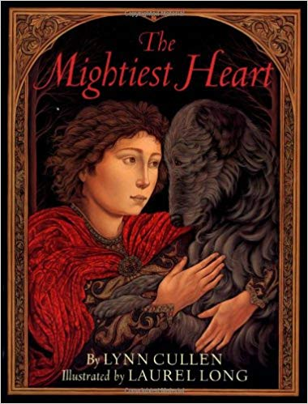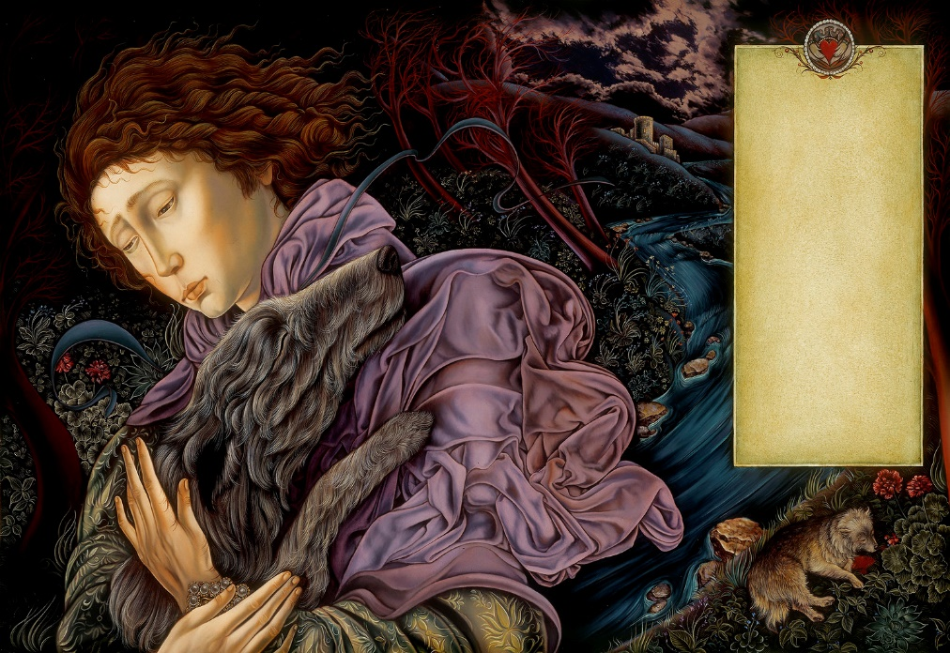
“In a remarkable debut, Long crafts oil paintings that resemble medieval tapestries: steeped in a wide array of greens, sprinkled with blood reds and burgundies and teeming with flower and fauna. Her close-up renderings of expressive faces against deep landscapes of rolling hills and turbulent skies give the tale an epic quality” (about The Mightiest Heart from Publishers Weekly)

Resources:
https://www.publishersweekly.com/978-0-8037-2292-7
http://miroirmagazine.com/2018/04/28/interview-with-artist-laurel-long/
https://www.laurellong.com/crmm4c532mbksw1vvdmyl2jpcvz4z6
https://www.goodreads.com/author/show/506873.Laurel_Long
https://www.youtube.com/watch?v=6RnuivICRn0

