Ways of Seeing
Publicity creates such an emotional pull on its viewers by making them unsatisfied with their current life and leaving them craving a better life where they are/they have what they aspire. When someone opens a magazine or looks at a website to shop, they are not looking at it for entertainment as they would be in a book or by watching a movie, but they are looking to purchase things they believe they need to be the best version of themselves. When someone doesn’t have the resources to become what they aspire, all they have is publicity and advertising to look at and remind themselves of what they are not and this creates quite a bit of stress and longing amongst people when they can’t become what they would like. When this longing happens, I believe this is when people continue to look at advertisements the most, as if they would like to stay there and live there forever instead of facing the reality of what their life is and what they already have.
Publicity draws upon the tradition of fine art in many ways but also contradicts fine art in other ways. One parallel between the two is the posing of the models to grab attention from the viewer; the posing is intentionally sexual and alluring and depicts beautiful women living a lavish lifestyle. In publicity, these women are supposed to be what other women aspire to be however in paintings, the women depicted were in present time and showing off what they already possessed. Another commonality between publicity and painting is the use of material objects such as clothing to convey wealth and status, in the paintings many of the objects portrayed were owned by the people purchasing the painting as a way for them to show off their wealth. In magazines and advertisements, wealth is something the viewers aim for and the objects in the ads are coveted by the viewers since they don’t own them already.
Some of the cultural signs publicity uses to make its arguments are: nostalgia, the educational background of the spectator-buyer, glamour. When it comes to nostalgia, the article talks about publicity “selling the past to the future”, which I interpret as using the trends and knowledge that the buyer already has in order to promote new trends. If the images in publicity have no tie to the past, then as the article says, there will be no credibility because the viewer will not know if the advertisement is sincere if it was only contemporary images. This also ties in with knowing the educational background of the spectator-buyer because publicity needs images that are relatable and known by their audiences. For example, a magazine wouldn’t want to show an image in an add that ties back to an old movie from the fifties if it’s geared towards people in their 20s because they wouldn’t be able to connect because the majority of them would not have seen the movie that was referenced. Another cultural sign used in publicity is glamour which is geared mainly towards women. When women see a beautiful woman in a magazine who has all the expensive jewelry, her hair and makeup done, flawless skin and body, along with whatever else the add is selling, they will envy that woman and want to be her. They will be more likely to buy something when they covet it because they have a reason to feel that they need it. To them, if they buy it they will be glamourous and loved and they will chase that feeling and keep spending money.
I am influenced by publicity every day even when I am unaware of it. I am not traditionally a person who wants material objects because I am very content with the things I do have but, in all honesty, I do sometimes feel a bit of jealousy towards the people portrayed in the ads, not because I necessarily want the things they have, but more of the ease of life they seem to have. I must work full time while also attending school full time because I don’t have anyone helping me through school because my parents can’t afford it and we don’t qualify for financial aid, so I have to pay much more money than the average student does. Though I obviously am aware that so many people have it much harder than I do, some days I look at advertisements and wish I could catch a break and go on vacation or buy organic food as funny as that sounds, and I get a little emotional about it sometimes because I feel that my hard work doesn’t get me very far in life and I aspire to be more than what I am now.
Part Two

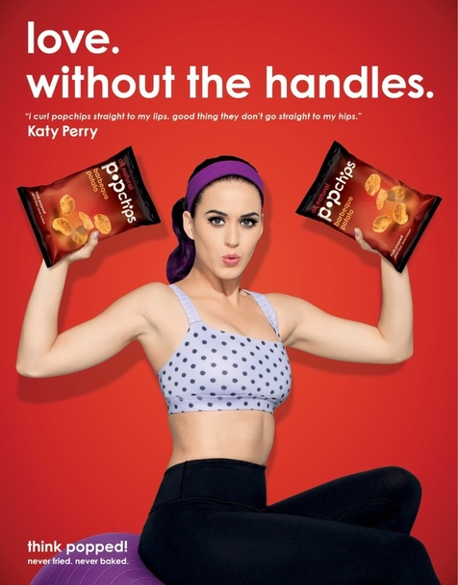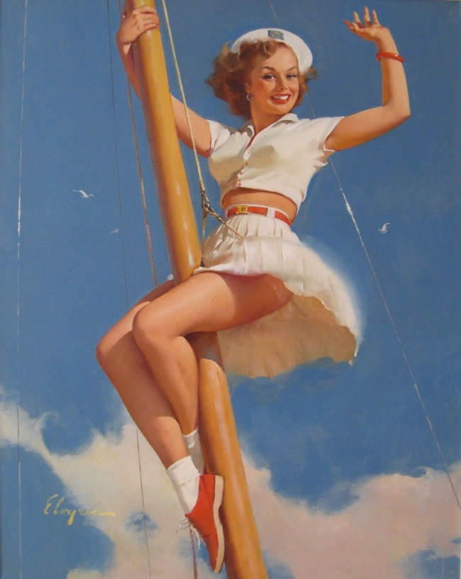
Pop Chips ad featuring Katy Perry Gil Elvgren Anchors A-Wow, 1968

The ad I chose is a popchips ad featuring Katy Perry that is promoting the chips because they are a healthier alternative to regular baked or fried chips. The ad features a strong, beautiful woman saying “I curl popchips straight to my lips, good thing they don’t go straight to my hips”, and holding two bags of popchips in her arms while making the muscle gesture as if she has been working out. The ad is saying that if you consume popchips instead of other chips, you will be skinny and fit like Katy Perry. It is saying this through the use of language and visual imagery to make viewers feel as if they must look like Katy Perry if they want to be successful/feel loved.
The first thing that I noticed about the ad of course was the way that they made Katy Perry look like a pin up girl from the 50s so naturally this ad reminded me of the work of Gil Elvgren, specifically the painting Anchors A-Wow from 1968. Both images are showing off the bodies of strong, busty women wearing revealing clothing. While in the popchips ad, Katy Perry is wearing sportswear, she isn’t wearing very much of it and her toned stomach and arms are 100% visible and right in the middle of the image so your eye goes straight to it. When women see this glamourous image, they will be envious of her body just like women would feel when looking at Elvgren’s pinup girls because at the time that was what the ideal female body was thought to be. While now the ideal body is fit and toned, in the 50s and 60s curvy bodies were thought of as ideal and were inspirations for many paintings. This knowledge would be an example of the cultural knowledge that Berger was talking about in the article because popchips knows its audience and what the ideal female body image is in America at this time.
The second thing I realized about this ad is the use of language and how prevalent/essential it is to the message that the viewers are receiving. Without the language, the viewers would be unsure of why Katy Perry is holding two bags of popchips and would probably skip past the ad however, the language tells the viewers/buyers exactly why they should consume popchips. Like I had said in the first paragraph, they are telling women that they will be fit if they eat popchips. The slogan “Love. Without the handles” relays the message that these chips will taste just as delicious and crave-worthy as the other chips, but won’t leave women with excess fat or “love handles” as we call them. This idea would entice women to buy these chips just to see how great they taste while also feeling better about what they are eating. The other line on the ad saying “I curl popchips straight to my lips, good thing they don’t go straight to my hips”, is very visual and I would say has a very subtle sexual undertone. This is saying that if women eat these chips, not only will they not gain weight, they will also be sexy and desirable and who doesn’t want that? Overall, this ad definitely does its job in luring buyers into purchasing this product, however it sheds light on very important cultural issues dealing with body image when taken apart.

